Lab 1

Lab 2 Buffer - Schematic and Simulation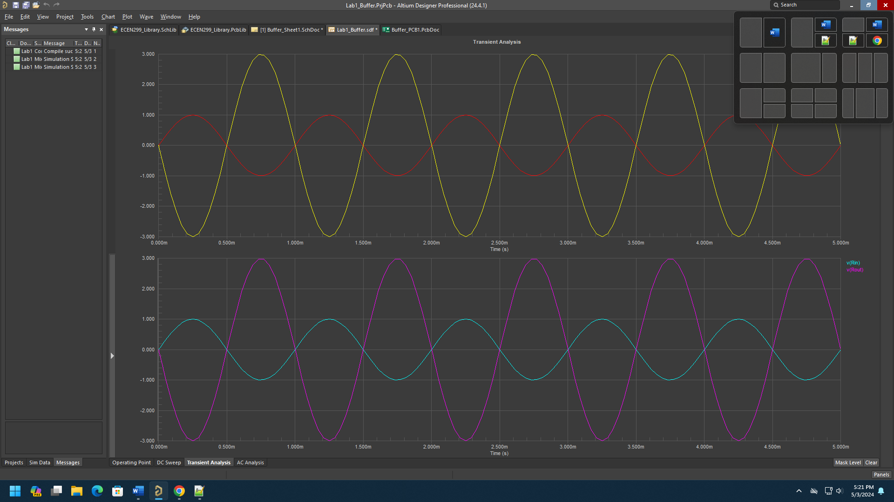

Ezra Senanu

5/3/2024

ECEN 250

**Objectives**

The objectives go here…

**Preliminary**

Preliminary stuff goes here…

This section deals with things that need to be done before starting the lab. For example, calculations of things you will be looking for during the lab, circuit designs that will be built during the lab, or explanations of the theory that will be applied or tested. There are some labs there the Preliminary Section is not applicable.

**Procedures**

**Equipment and supplies**

* Include equipment here

**Procedure**

Step by step instructions go here. Feel free to include references to the lab instruction documents to avoid repeating detailed steps, but make sure you include all the necessary information specified in the instructions (see Table 1 and Figure 1), such as screenshots of schematics, layouts, simulations, tables, and whatever else is mentioned. You should especially include any calculations you make and explanations of each of the items you add to the report. Also make sure that each of your figures has a title (such as "Figure 1, Completed PCB"). Make reference to them in your procedures, including an explanation of what they are and what they mean. For example, “The measured rise time, fall time, and percent overshoot are shown in Table 1.”

**Table 1: Name of Data**

|  |  |  |
| --- | --- | --- |
|  | Calculated | Measured |
| Rise Time | 2.0 sec | 2.4 sec |
| Fall Time | 1.5 sec | 1.6 sec |
| Percent Overshoot | 10.0 % | 8.2% |

Include more steps… After measuring the output with the oscilloscope, I found the steady state error to be 1, as shown in the waveform in Figure 1.

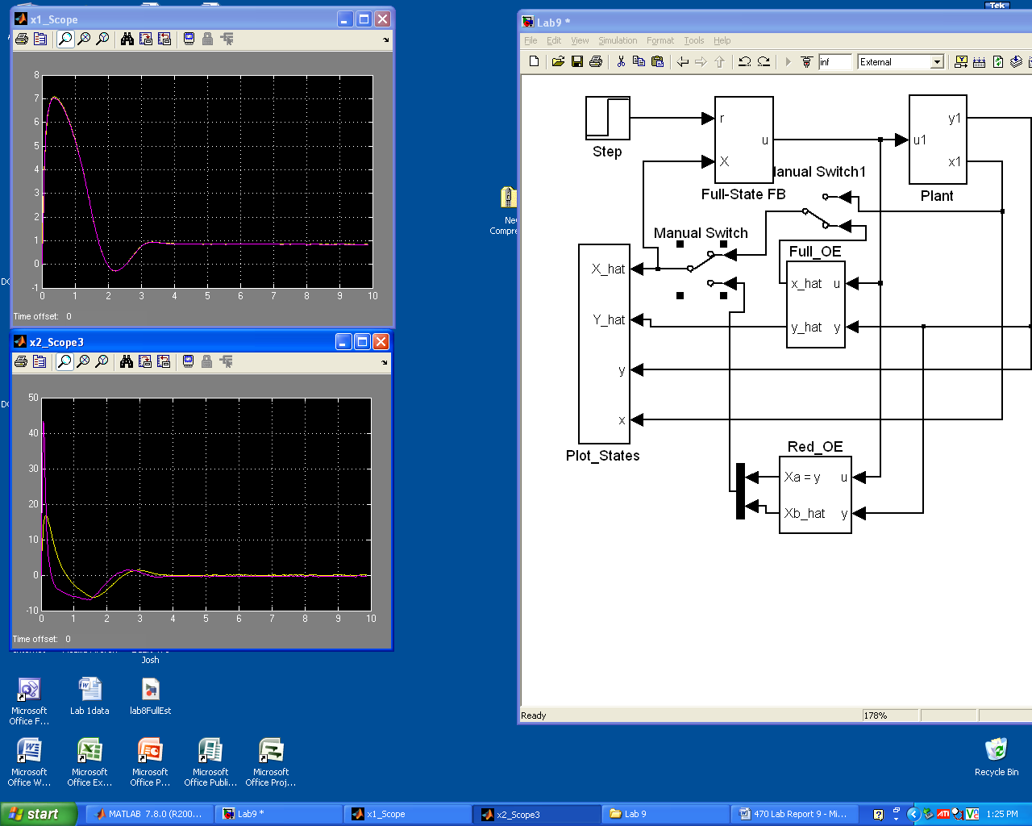

**Figure 1: Steady State Error**

The step by step procedure should not be cut and pasted from the lab instructions. Rather, it should be put in your own words. If it make sense to do so, some steps can be summarized in your report and the reader can be referred to the lab instructions for the more tedious detailed procedures, but remember that pictures and a couples sentences are not enough alone. Have enough detail in the procedure section so that the reader can understand what was being done and follow the steps used to accomplish the lab.

**Conclusion**

Conclusion goes here and is more than a few lines. This is the only section (other than images) that must be unique to each lab partner. It must include information specified in the lab instructions, as well as a more detailed explanation of what problems you encountered and information about how you overcame them…

A note about lab partners and lab reports. There will be times when you are required to include a picture of something you made in your lab report, such as a PCB that you soldered. These must be specific to you and not a copy of your partner’s. The same applies for all Conclusion sections. Everything else can be identical to the report your partner submits.

Paste a copy of lab verification here…